**Name : Allah dad**

**Section : “D”**

**CMS:023-22-0056**

**Lab#04**

Exercise 1 Vehicle.java

Create a class Vehicle. The class should have two fields-no_of_seats and no_of_wheels. Create two objects-Motorcycle and Car for this class. Your output should show the descriptions for Car and Motorcycle.

**Input**

**import java.util.Scanner;**

**class Vehicle**

**{**

**int no_seat;**

**int no_wheel;**

**public void mymethod()**

**{**

**System.out.println("No of seats:"+this.no_seat);**

**System.out.println("No of wheels:"+this.no_wheel);**

**}**

**public static void main(String args[])**

**{**

**Scanner ip=new Scanner(System.in);**

**Vehicle car=new Vehicle();**

**Vehicle motorcycle=new Vehicle();**

**System.out.println("Enter the number of seats,wheels of car:");**

**car.no_seat=ip.nextInt();**

**car.no_wheel=ip.nextInt();**

**System.out.println("Enter the number of seats,wheels of motorcyle:");**

**motorcycle.no_seat=ip.nextInt();**

**motorcycle.no_wheel=ip.nextInt();**

**System.out.println("Car");**

**car.mymethod();**

**System.out.println("Motorcyle");**

**motorcycle.mymethod();**

**}**

**}**

**Output**

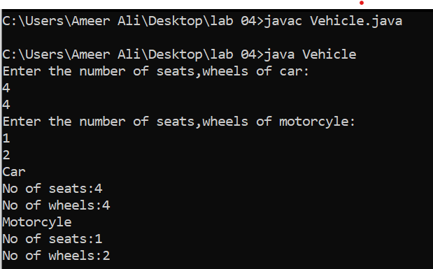

Exercise 2 Employee.java

Write a program that would print the information (name, year of joining, salary, address) of three employees by creating a class named 'Employee'. The output should be as follows:  
Name        Year of joining       Address  
Asif            2022                 Daharki  
Ahmed       2021                 Ghotki  
Shoaib       2010                 Sukkur

Shahzeb 2020 Hyderabad

**Input**

**import java.util.Scanner;**

**class Employee**

**{**

**Scanner ip=new Scanner(System.in);**

**String name;**

**int joining;**

**String Adress;**

**void information()**

**{**

**System.out.println("Name:"+this.name);**

**System.out.println("Joinig of the year:"+this.joining);**

**System.out.println("Adress:"+this.Adress);**

**}**

**public static void main(String args[])**

**{**

**Employee ob1=new Employee();**

**Employee ob2=new Employee();**

**Employee ob3=new Employee();**

**Employee ob4=new Employee();**

**ob1.name="Asif";**

**ob2.name="Ahmed";**

**ob3.name="Shoaib";**

**ob4.name="Shahzeb";**

**ob1.joining=2013;**

**ob2.joining=2014;**

**ob3.joining=2015;**

**ob4.joining=2016;**

**ob1.Adress="Ghotki";**

**ob2.Adress="Daharki";**

**ob3.Adress="Sukkur";**

**ob4.Adress="Larkana";**

**ob1.information();**

**System.out.println("\n\n\n");**

**ob2.information();**

**System.out.println("\n\n\n");**

**ob3.information();**

**System.out.println("\n\n\n");**

**ob4.information();**

**}**

**}**

**Output**

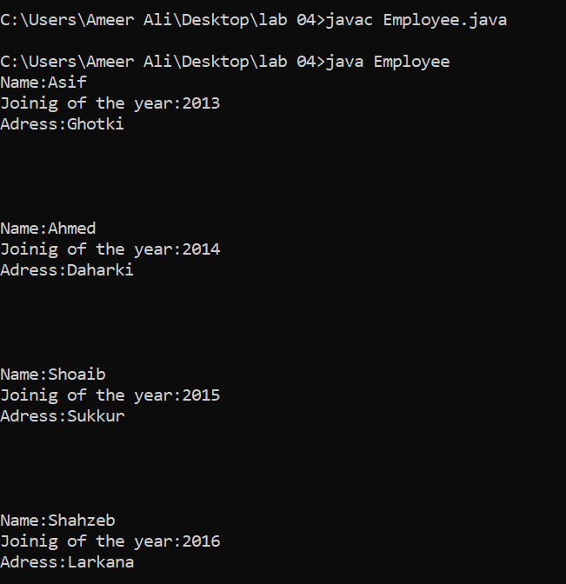

Exercise 3 EmployeeInfo.java

Write a program by creating an 'EmployeeInfo' class having the following methods and print the final salary.  
1 - 'getInfo()' which takes the salary, number of hours of work per day of employee as parameter  
2 - 'AddWork()' which adds $5 to salary of employee if the number of hours of work per day is more than 6 hours.

**Input**

**import java.util.Scanner;**

**class Employeeinfo**

**{**

**public static void getinfo(int salary,int hours)**

**{**

**if(hours>6)**

**{**

**System.out.print("Final Salary :"+(salary+5)+"$");**

**}**

**else**

**{**

**System.out.print("Final Salary :"+salary+"$");**

**}**

**}**

**public static void main(String args[])**

**{**

**int salary;**

**int hours;**

**Scanner ip=new Scanner(System.in);**

**System.out.print("Enter the salary :");**

**salary=ip.nextInt();**

**System.out.print("Enter the hours :");**

**hours=ip.nextInt();**

**getinfo(salary,hours);**

**}**

**}**

**Output**

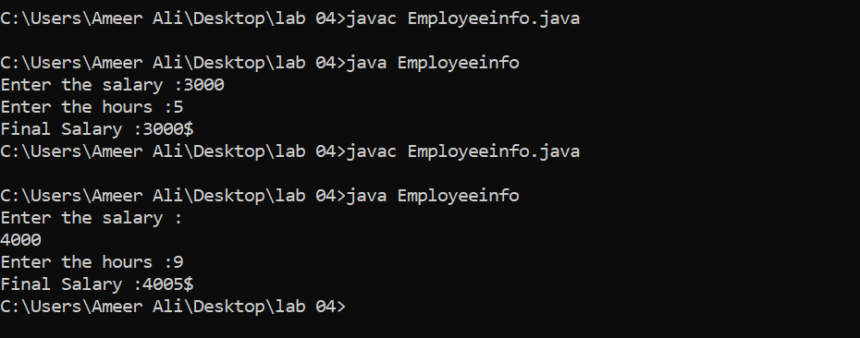

**Exercise 4 Dice.java**

Write a program that generate random number from 1-6. It should take input from the user if user enter Y then it should generate another random number. If user enter N then program should display total score.

Random number: 5

Do you want to play game Y/N: Y

Random number : 3

Do you want to play game Y/N: Y

Random number: 2

Do you want to play game Y/N: N

Total score: 10

Dice rolled: 3

**Input**

**import java.util.Random;**

**import java.util.Scanner;**

**class Q4**

**{**

**public static void main(String args[])**

**{**

**Random random=new Random();**

**Scanner ip=new Scanner(System.in);**

**int sum=0;**

**int dice=1;**

**int i=0;**

**do**

**{**

**System.out.print("\nDo you want to play game N/Y:");**

**char alp=ip.next().charAt(0);**

**if(alp=='y')**

**{**

**int no=random.nextInt(10);**

**System.out.print("\n"+no);**

**sum+=no;**

**dice+=1;**

**}**

**else if(alp=='n')**

**{**

**break;**

**}**

**i++;**

**}**

**while(i>0) ;**

**System.out.print("Total score :"+sum+"\n");**

**System.out.print("Dice rolled :"+dice);**

**}**

**}**

**Output**

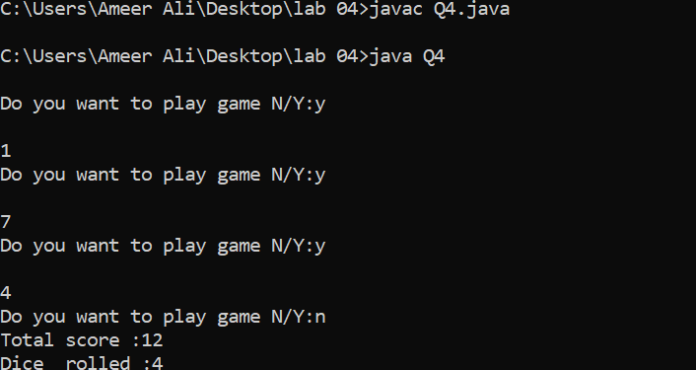

**Exercise 5 Year.java**

Write a program that inputs the year, a person is born in and returns the age of the person.

Example: Person born in 1991 then age is 30

**Input**

**import java.util.Scanner;**

**class Q5**

**{**

**public static int mymethod()**

**{**

**Scanner ip=new Scanner(System.in);**

**System.out.print("Enter the age:");**

**int age=ip.nextInt();**

**age=(2023-age);**

**return age;**

**}**

**public static void main(String args[])**

**{**

**System.out.print(" age is "+mymethod());**

**}**

**}**

**Output**

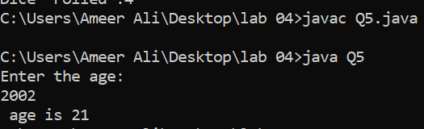

**Q1:** Can constructors be private?

Ans : Yes, we can made constructor private by using private keyword . After using private keyword than it will accessed in same class not in other class.

Q2: Can a non-static method access a static variable or call a static method?

Ans:yes we call the the static method in the non static method .when we call the non static method in the main the code will execute.

For example:

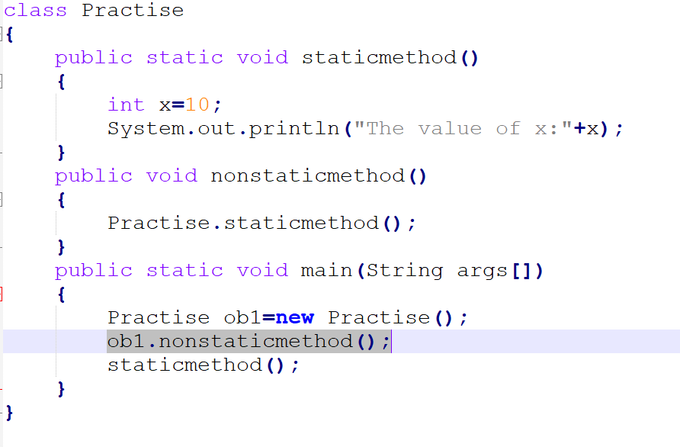

Q3: State differences between java constructor and java methods

Ans:Constructor name is same as of class and no return type but java method has return the values and also can give different names.